**SMART HEALTH MONITORING SYSTEM**

**1.INTRODUCTION**

Health is a one of the most important factor for human being’s to maintain a good health condition then good health care system needed. Now a day’s Health care system more important present situation’s like covid pandemic. And also Health care System is needed for the Aged peoples and also for physical challenged people. To overcome from this scenario Remote health Monitoring system is better solution.

In rapid growth of technologies IOT is best platform for the remote based health monitoring system. IOT based health monitoring service helps in preventing the rapid spread of disease like covid-19 and also as well as to get know a proper diagnosis for that disease, even in the situation where physician is unavailable.

A smart health monitoring system we introduced a in Manner which continuously monitors the patient health condition and automatically sends the data to server and also view in the website. So the physician can access patient data continuously and we can intimate caretaker to advice patient health condition. In this project we came up with a proposal on nonstop health checking and control instrument to check the patient s condition and store the patient information in database server. Where the authorized Medical Officer can access through Website these data stored In the Data Base The particular diseases are virtually diagnosed by the doctors from a far distance.

**1.1 PROBLEM STATEMENT**

The global health problem has been increasing day by day due of poor health services and lack of medical experts and lack of hospital in ruler area due to high quality hospitals poor people not get the popper health care from financial problems. And many patients are not getting proper help during this pandemic situation and it is difficult for the doctors in pandemic situation.

**1.2 Solution**

The IOT based remote health monitoring is best choice for good health care system. And also In this project we came up with a proposal on nonstop health checking. By the using the battery power and solar power continually health is monitored. With the sensors like temperature sensor, pulse and ECG sensor, is used to know the health condition of patient. And by using GSM Module the patient condition doctor can virtually diagnosed by the from a far distance.

**1.3 DEFINITIION**

A Health Monitoring System (HMS) is a sophisticated technology and an volition to the traditional operation of case and their health.

Smart health monitoring system is begin developing using IOT technology which is capable of monitoring pulse sensor, temperature sensor, humidity of a person.

**1.4 REFERENCES**

1. Rahaman A, Islam M, Islam M, Sadi M, Nooruddin S. Developing IoT based smart health monitoring systems: a review. Rev Intell Artif. 2019;33:435–40. https://doi.org/10.18280/ria.330605.
2. Lin T, Rivano H, Le Mouel F. A survey of smart parking solutions. IEEE Trans Intell Transp Syst. 2017;18:3229–53. https://doi.org/10.1109/TITS.2017.2685143

**List of Abbreviation**

* ANALOG IN………………………….Analog input
* DIGITAL PIN………………………..Arduino Uno rev 3 has 14 digital pins (0-13)
* I2C…………………………………………Integrated circuit
* VCC………………………..…………....Digital Power Supply
* GND………………….………….……….Ground
* I…………………………..……………......Current
* I/F…………………………………….....Interface
* P……………………………..…………….Power(W=Watt)
* R……………………………...…………..Resistance
* IMU……………………..…………….…Inertial measurement unit
* LDR……………………………………….Light dependent resistor
* LED…………………………..…………..Light emitting diode
* U……………………………………………Voltage(V)
* Vin………………………...…………….Power pin max 1000mA
* Voltage divider……………….U out=R2/(R1+R2)*U in

**2.Functional And Non Functional Requirements**

**Functional requirement:**

* Arduino Uno
* Power supply
* Battery
* Pulse sensor
* Temperature sensor
* Humidity sensor
* ECG sensor
* GSM
* Solar panel
* LCD display

**NON FUCTIONAL REQUIREMENTS:**

* Arduino Uno Ide:-Embedded C

**3.BLOCK DIAGRAM**

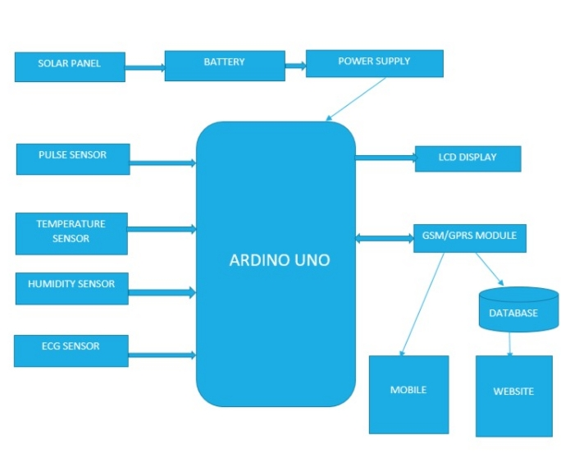

**4 .DATA FLOW DIAGRAM**

**LEVEL 1**

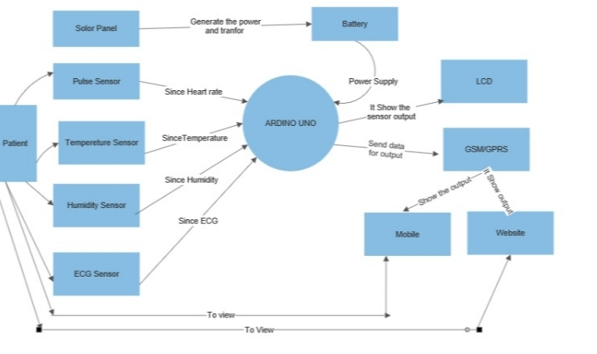

**LEVEL 2**

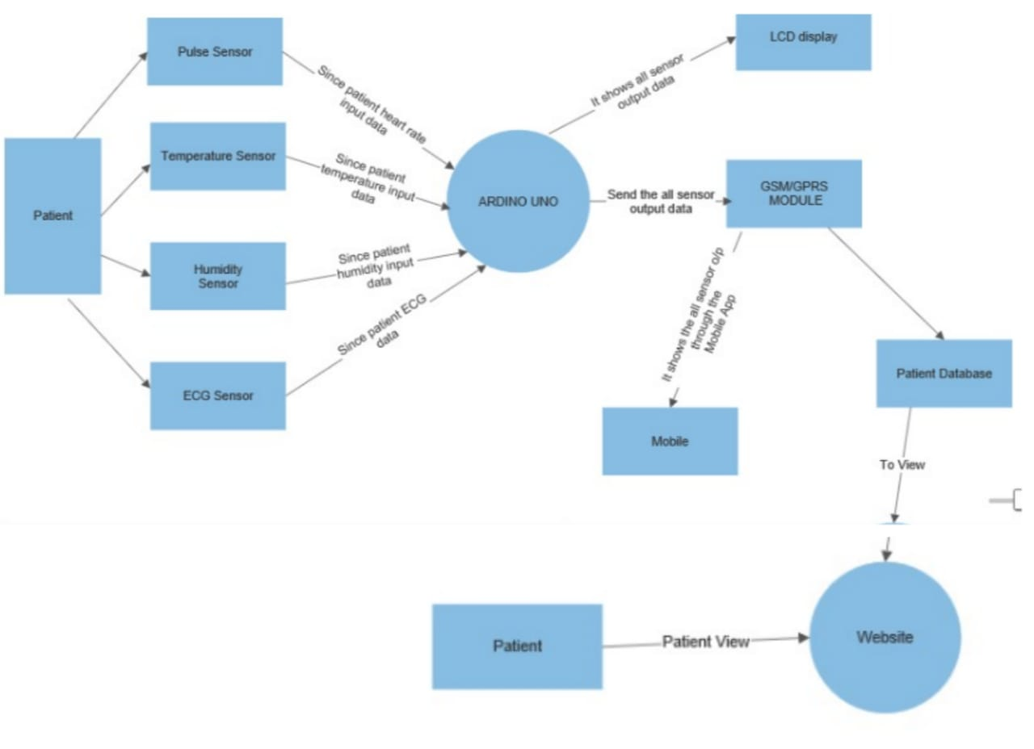

**LEVEL 3**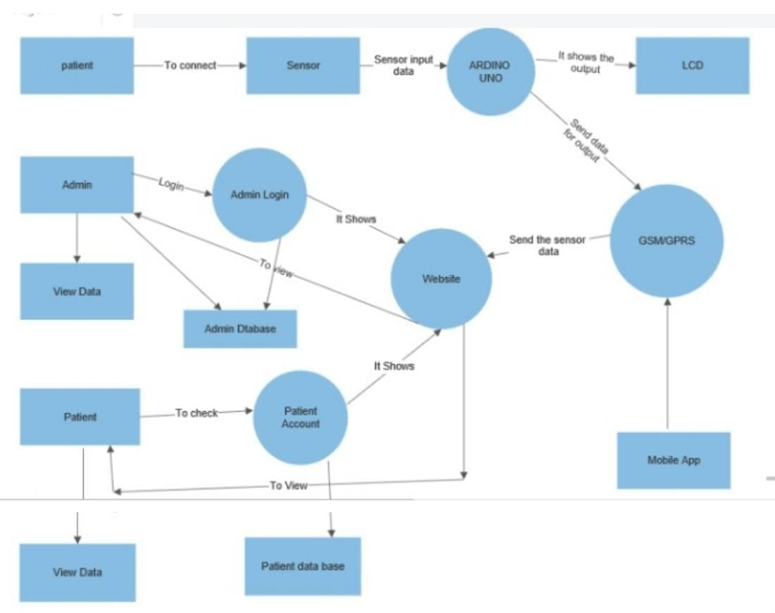

**5.CONCLUSION**

An efficient SHMS is developed to monitor the up to date status of the patient irrespective of the presence of the doctor. The system collects information like temperature, blood pressure and pulse rate of the patient and updates the same to the doctor. The system is evaluated experimentally and collected the sample data of ten patients to verify the status of patients. The doctor can monitor the progress of patients' health now and then to advise them about their health.